ZOOM



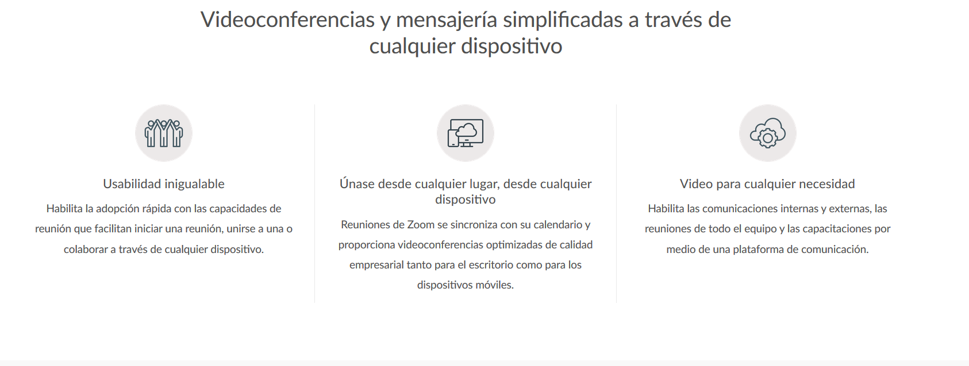

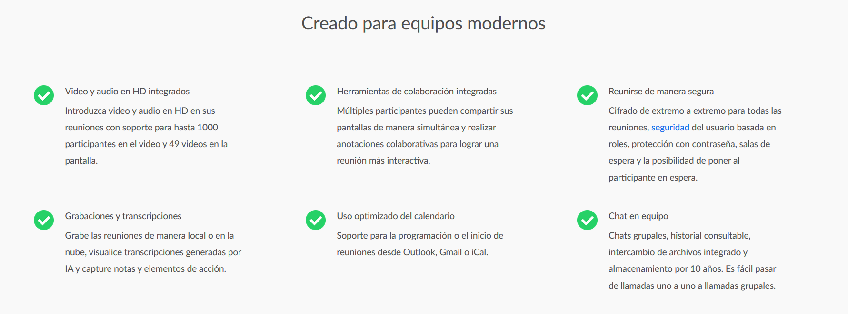

Webex



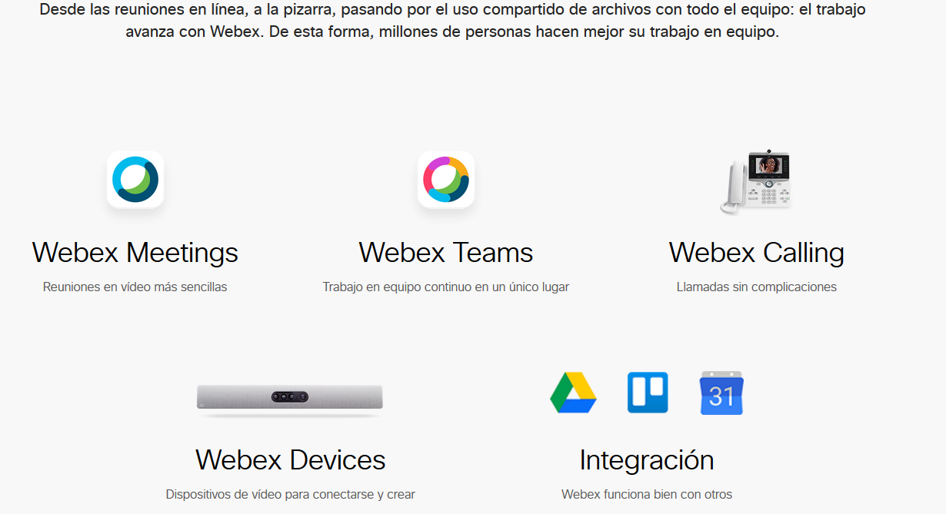

Microsoft Teams

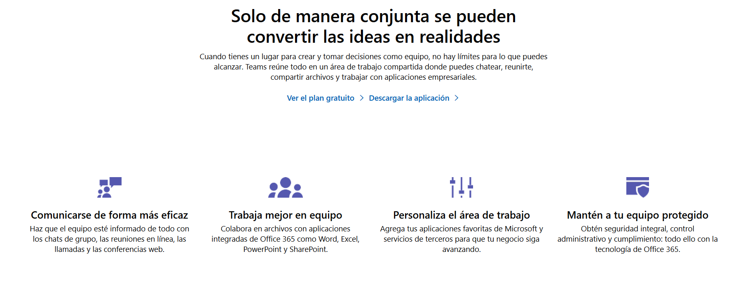

Comparativo

|  |  |  |  |
| --- | --- | --- | --- |
|  | Zoom | Webex | Microsoft Teams |
| Video Llamada | X | X | X |
|  |  |  |  |
|  |  |  |  |
|  |  |  |  |
|  |  |  |  |
|  |  |  |  |
|  |  |  |  |